Bluetooth beacon navigation

Thomas Van Raemdonck Wouter Vande velde

2017

# Introduction

The project is about geolocation inside a certain room. Using 4 bluetooth beacons, a room will be covered by a bluetooth connection. The challenge is to see the location of a smartphone as accurate as possible inside the room.

A few examples where this idea can be possible in real life are

* the locations of clients inside a store and their pathing
* the location of babies inside a nursery
* the location of patients with for example Alzheimer's
* …

# Indoor navigation using Bluetooth

Bluetooth communicates over small distances on the 2.4 GHz ISM frequency band. Bluetooth uses 79 channels to transmit data, starting with the first channel at a frequency of 2402 MHz and continuing up to the last one at a frequency of 2480 MHz in 1 MHz increments.

In order to transmit data, Bluetooth devices must first stablish a connection. One single device is capable of connecting to up to 7 devices and communicating with each one of them simultaneously. This is done by using a connection model known as “master-slave”, in which the device that initiates the connection takes the role of master over the other devices. Whenever a master and a slave establish a connection, a bond is created, enabling them to transmit and receive data.

Bluetooth is also known for indoor navigation purposes. In this casa a connection is not necessary. Because there is no data exchange between devices.

# Bluetooth Beacons

The devices that are used in the project are 4 beacons produced by Skylab setup in a rectangular shape inside a certain room. The beacons that are used, are produced by Skylab and have the following specifications:

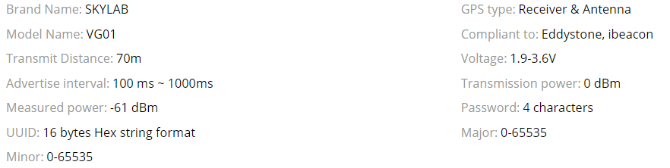

[Link to the webpage.](https://www.aliexpress.com/item/017-SKYLAB-70m-Programming-UUID-Proximity-nordic-nRF51822-ibeacon-receiver-bluetooth-low-energy-Bluetooth-beacon/32758033405.html?ws_ab_test=searchweb0_0,searchweb201602_5_10152_10065_10151_10344_10068_10345_10342_10343_10340_10341_10541_10084_10083_10304_10307_10301_10177_10060_10155_10154_10056_10055_10539_10537_10312_10536_10059_10313_10314_10534_10533_100031_10550_10103_10073_10551_10102_10552_10553_10554_10557_10142_10107,searchweb201603_25,ppcSwitch_5&btsid=c9ff4ec4-8e01-4147-9fda-daecbb29e1fe&algo_expid=8aeb9b93-e9f2-4a25-92da-5a3445050c8f-3&algo_pvid=8aeb9b93-e9f2-4a25-92da-5a3445050c8f#thf)

### Beacon protocol

Eddystone

Eddystone is an open beacon protocol developed by Google.

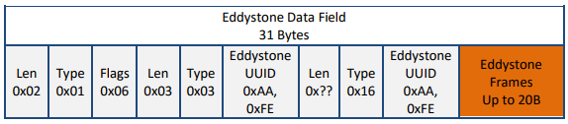

# Indoor Navigation Methods

### Triangulation

# Similar projects

### Project 1

[INDOOR NAVIGATION USING BLUETOOTH LOW ENERGY (BLE) BEACONS](http://theseus56-kk.lib.helsinki.fi/bitstream/handle/10024/105619/Herrera%20Vargas_Milan.pdf?sequence=1&isAllowed=y)

The project is created in 2016 by Milan Herrera Vargas. It shows the concept of indoor navigation with the help of Bluetooth beacons. The difference between our project and the described project is that the described project measures the locations in a building while our project only goes in one room. Since walls don’t really affect Bluetooth, the project is very similar.

Milan measures the distance using the average RSSI measurements at predefined distances he collected himself seen in following table:

A screenshot of a cell phone

Description generated with very high confidence

Figure 1: Average RSSI measurements at predefined distances

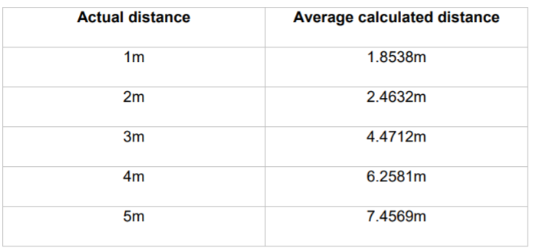He then used these values to calculate the distance from the beacon to a device, the beacon sends out a signal every 30 seconds. After a test of 300 recorded values comparing the actual and the measured distances, he could conclude the results were fairly accurate. The results were quite good at distances closer than 3m and got less accurate at longer distances. He also notes that if there is no clear line of sight between the beacon and the device, the results might get affected.

Figure 2: Comparison between calculated and actual distances

### Project 2

[How to do accurate indoor positioning with Bluetooth beacons?](https://proximi.io/accurate-indoor-positioning-bluetooth-beacons/)

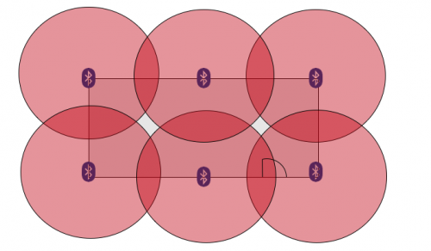The project talks about how beacons cannot measure distances but that they are merely like ‘lighthouses’ that send out signals. That why trilateration is used, the project talks about how you need 3 or more beacons to get an accurate location. The RSSI values of each of them will help you to calculate the distance between the device and the beacons as is shown in following image.

Figure 3: beacon positions in square shaped room

The best location in a room to place the beacons are on a regular and evenly basis in the environment, as shown in the picture above. It is also optimal to hang them on walls, preferably on 2m height. The article also suggests it is important to pay attention to the transmission power and interval and the maximum beacon range, it is best to adjust these values according to the environment the beacons are used in.

### Project 3

[Wayfinder: indoors routing guided by Beacons](https://www.onyxbeacon.com/wayfinder-indoors-routing-guided-by-beacons/)

This project is less relevant since it talks more about the pathing inside a building with the use of beacons. In our project we will mainly focus on the location and less on the pathing. The app created in the project is called Onyx Beacon’s Wayfinder. It shows the most optimal route in a building according to the points of interest principle and it will offer step by step indication for indoors navigation. The user will get an overview of the route and individual instruction on next steps to reach the destination. The distances between the beacons are 25 to 40 meters.

### Project 4

[Indoor positioning with beacons and mobile devices](http://bits.citrusbyte.com/indoor-positioning-with-beacons/http:/bits.citrusbyte.com/indoor-positioning-with-beacons/)

The method used in the project for estimation position using distance is trilateration.

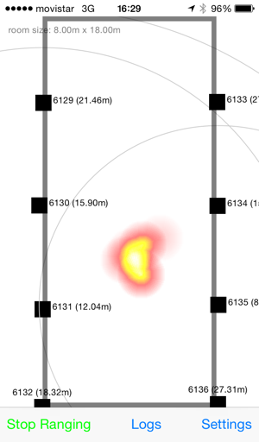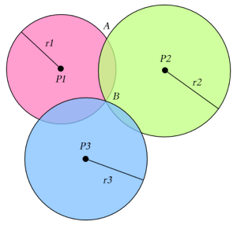In a N dimensional world, there are N+1 reference points needed: so in a 2D area there are 3 beacons needed to get an accurate position as is shown in following image:

Figure 4: heatmap of a room

Figure 5: trilateration

The experiment that was conducted in the project shows that is hard to find a satisfactory solution. Therefore they made use of heatmaps and a large set of data to get a probability area that tells where the device may be found. This is shown in following image:

The room that is used is a big hall of 8m x 18m and the beacons were placed around 2.5m high on the walls.

The article suggests to use an signal as strong as possible to get the most accurate signals, it also says to put the beacons as high as possible and the more beacons the better.